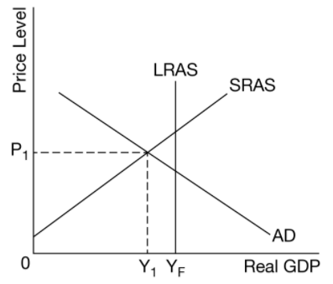
6.4 APQB – Exchange Rate Market

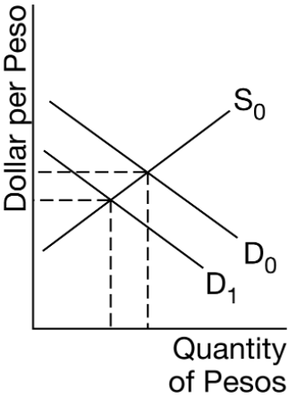
- Which of the following best explains the change in the international value of the peso caused by a shift of the demand curve from D0 to D1 in the dollar-peso foreign exchange market?
- The peso has appreciated because Americans’ demand for Mexican financial assets increased.
- The peso has appreciated because Mexicans’ demand for United States financial assets increased.
- The peso has depreciated because Americans’ demand for Mexican goods and services decreased.
- The peso has depreciated because Mexicans’ demand for American goods and services decreased.
- The peso has depreciated because Americans are unwilling to sell products to Mexico.
- Which of the following monetary policy actions by the Federal Reserve would result in an appreciation of the United States dollar?
- An open-market purchase of government bonds
- An open-market sale of government bonds
- A decrease in the discount rate
- A decrease in the required reserve ratio
- An increase in the money supply
- The diagram shows an economy’s long-run aggregate supply (LRAS) , short-run aggregate supply (SRAS) , and aggregate demand (AD) . Assume the country’s economy is currently at short-run equilibrium. Which of the following is a monetary policy action the country’s central bank can use to restore full employment, and what is the consequent effect on the value of the country’s currency in foreign exchange markets?
- A decrease in the money supply, which will cause currency depreciation.
- A decrease in the discount rate, which will cause currency appreciation.
- An increase in the required reserve ratio, which will cause currency appreciation.
- An open market sale of government bonds, which will cause currency appreciation.
- An open market purchase of government bonds, which will cause currency depreciation.
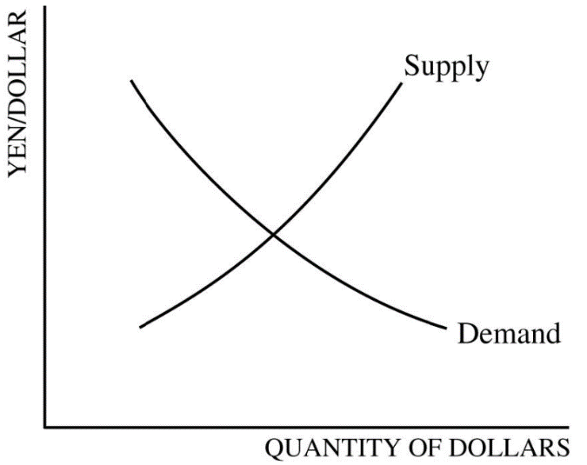
- The graph above shows the foreign exchange market for United States dollars in terms of Japanese yen. Assume that there is an increase in United States consumers’ preference for Japanese automobiles. Which of the following changes will most likely take place in the market for dollars?
- It will take more yen to purchase the same amount of dollars.
- The demand for dollars will increase.
- The supply of dollars will increase.
- Both the demand for and the supply of dollars will decrease.
- There will be no change in the foreign exchange market.
- An appreciation of the United States dollar on the foreign exchange market could be caused by a decrease in which of the following?
- United States interest rates
- The United States consumer price index
- Demand for the dollar by United States residents
- Exports from the United States
- The tariff on goods imported into the United States
- In a flexible system of exchange rates, an open market sale of bonds by the Federal Reserve will most likely change the money supply, the interest rate, and the value of the United States dollar in which of the following ways?
- Money Supply: Increase, Interest Rate: Decrease, Value of the Dollar: Decrease
- Money Supply: Increase, Interest Rate: Decrease, Value of the Dollar: Increase
- Money Supply: Decrease, Interest Rate: Decrease, Value of the Dollar: Decrease
- Money Supply: Decrease, Interest Rate: Increase, Value of the Dollar: Increase
- Money Supply: Decrease, Interest Rate: Increase, Value of the Dollar: Decrease
- The United States government is running a budget deficit. What will most likely happen to the United States dollar in the foreign exchange market?
- Appreciate because interest rates will increase.
- Depreciate because interest rates will decrease.
- Appreciate because interest rates will decrease.
- Depreciate because interest rates will increase.
- Not change because the budget deficit has no effect on the exchange rate.
- Suppose that Country A is experiencing high inflation relative to Country B, which is enjoying steady growth with a stable price level. Which of the following would occur in the foreign exchange market?
- An increase in the demand for Country A’s currency
- An increase in the supply of Country B’s currency
- A decrease in the supply of Country A’s currency
- A decrease in the demand for Country B’s currency
- A depreciation of Country A’s currency
- Assume that the inflation rate in Country X is very high relative to the inflation rates in all of its trading partners. Which of the following is likely to happen to Country X’s currency on the foreign exchange market?
- The demand curve for the currency will shift to the right, and the currency will appreciate.
- The demand curve for the currency will shift to the left, and the currency will depreciate.
- The supply curve for the currency will shift to the left, and the currency will appreciate.
- The supply curve for the currency will shift to the left, and the currency will depreciate.
- There will be no shift in the demand curve for the currency, but the currency will depreciate.
- An expansionary fiscal policy financed by government borrowing will most likely lead to which of the following changes in the real interest rate and the value of the country’s currency?
- The real interest rate will increase, and the currency will appreciate.
- The real interest rate will increase, and the currency will not change.
- The real interest rate will not change, and the currency will not change.
- The real interest rate will decrease, and the currency will depreciate.
- The real interest rate will decrease, and the currency will appreciate.
- Assume that Country X and Country Y are trading partners. If the average income in Country X increases, which of the following will occur in the foreign exchange market?
- The demand for Country X’s currency will increase, and Country X’s currency will appreciate.
- The demand for Country Y’s currency will increase, and Country X’s currency will depreciate.
- The demand for Country Y’s currency will increase, and Country X’s currency will appreciate.
- The supply of Country X’s currency will decrease, and Country X’s currency will appreciate.
- The supply of Country Y’s currency will increase, and Country Y’s currency will depreciate.
- Which of the following will most likely cause a depreciation in a country’s currency?
- An increase in the country’s price level
- An increase in the country’s real interest rate
- A decrease in the country’s expected inflation
- A decrease in the country’s real gross domestic product
- A decrease in the country’s money supply
- If foreign financial investors no longer see country A as a safe haven, which of the following will most likely occur in the short run?
- Country A’s currency will appreciate.
- Country A’s currency will depreciate.
- Country A’s current account will move toward deficit.
- Country A’s financial account will move toward surplus.
- Tariff revenues received by country A will decrease as investors seek investment elsewhere.
- Tariffs are different from assigned import quotas in that tariffs will
- restrict imports
- increase the price of imported goods
- benefit domestic consumers of imported goods
- hurt domestic producers of goods facing import competition
- generate additional revenue for the domestic government
- Country A both imports and produces tea. If Country A imposes a tariff on imported tea, which of the following will occur?
- Tea consumption will increase.
- Domestic tea production will decrease.
- Employment in the domestic tea industry will increase.
- The domestic price of tea will decrease.
- Country A’s currency will depreciate.
- The value of a country’s currency will tend to appreciate if
- demand for the country’s exports increases
- the country’s money supply increases
- the country’s citizens increase their travel abroad
- domestic interest rates decrease
Answers

1C 2B 3E 4C 5B 6D 7A 8E 9B 10A 11B 12A 13B 14E 15C 16A 17E 18C 19A 20C
- tariffs on the country’s imports decrease
- Which of the following is likely to cause the currency of Country Z to appreciate in the short run?
- Country Z decreases its interest rates.
- Country Z pursues an expansionary monetary policy.
- Country Z’s price level increases.
- Country W, a neighboring country, increases its real interest rates.
- Country G’s residents increase their demand for Country Z’s goods.
- Which of the following will lead to a depreciation of a nation’s currency?
- Lower inflation in the nation than in the rest of the world
- Higher required reserve ratio in the nation than in the rest of the world
- Decreased real interest rates in the nation compared with the rest of the world
- Increased demand for the nation’s currency
- Decreased supply of the nation’s currency
- Which of the following will cause the United States dollar to depreciate relative to the euro?
- An increase in household income in the United States
- An increase in interest rates in the United States
- An increase in household income in Europe
- A decrease in interest rates in Europe
- A decrease in price level in the United States
- An increase in United States imports will result in which of the following in foreign exchange markets?
- Increased foreign demand for United States dollars
- Decreased supply of United States dollars
- Increased United States demand for foreign currencies
- A decrease in the value of foreign currencies
- An increase in the value of the United States dollar

Free Response

- Include correctly labeled diagrams, if useful or required, in explaining your answers. A correctly labeled diagram must have all axes and curves clearly labeled and must show directional changes. If the question prompts you to “Calculate,” you must show how you arrived at your final answer.
Assume the Canadian economy is currently in recession and the government budget is in deficit.
(a) Draw a single correctly labeled graph with both the short-run and long-run Phillips curves for the Canadian economy. Label the current short-run equilibrium as point X.
(b) Assume the government increases its deficit spending to restore full employment. What effect will this have on real interest rates in Canada? Explain.
(c) Based on your answer to part (b), what will happen to financial capital flows to Canada?
(d) Canada and Norway are major trading partners. The exchange rate between the Canadian dollar and Norway’s currency, the krone, is determined in a flexible foreign exchange market. Draw a correctly labeled graph of the foreign exchange market for the Canadian dollar, and show the effect of the change in real interest rates identified in part (b) on the equilibrium exchange rate of the Canadian dollar.
(e) Given your answer to part (d), what will happen to the international value of the Norwegian krone?
(f) Assume Norway’s current account balance is zero. As a result of the change in the value of the krone you identified in part (e), will Norway’s current account be in deficit, surplus, or stay the same? Explain.
(g) What effect will the change in the value of the Canadian dollar in part (d) have on Canada’s net exports?
(h) On your graph in part (a) show the effect of the change in Canada’s net exports identified in part (g) and label the new short-run equilibrium as point Z.
- Include correctly labeled diagrams, if useful or required, in explaining your answers. A correctly labeled diagram must have all axes and curves clearly labeled and must show directional changes. If the question prompts you to “Calculate,” you must show how you arrived at your final answer.
Respond to all parts of the question.
The United States is currently in a recession with an output gap of $500 billion.
(a) Draw a correctly labeled graph of the aggregate demand, short-run aggregate supply, and long-run aggregate supply curves, and show each of the following.
(i) The current equilibrium real output and price level, labeled as Y1 and PL1, respectively
(ii) The full-employment output, labeled as Yf
(b) If the marginal propensity to consume in the United States is 0.8, calculate the minimum amount of government spending required to increase aggregate demand by the amount of the recessionary output gap of $500 billion. Show your work.
(c) Suppose instead the government decides to reduce personal income taxes with no change in government spending. In order to increase aggregate demand by the amount of the recessionary output gap of $500 billion, would the tax cut need to be greater than, less than, or equal to the change in government spending identified in part (b)? Explain.
(d) On your graph in part (a), show the impact of the tax cut on the short-run equilibrium price level, labeling the new price level as PL2.
(e) Draw a correctly labeled graph of the money market. Show the impact of an increase in nominal gross domestic product on the equilibrium nominal interest rate.
(f) Based on your answer to part (e), what will happen to real interest rates in the United States assuming there is no change in inflationary expectations?
(g) Based solely on the real interest rate change in part (f), what will happen to each of the following?
(i) The demand for the dollar in the foreign exchange market. Explain.
(ii) The stock of physical capital. Explain

- Assume the economy of Sweden is in long-run equilibrium and has a surplus in its current account.
(a) Is the Swedish capital and financial account in deficit, in surplus, or in balance? Explain.
(b) Draw a correctly labeled graph of short-run aggregate supply, long-run aggregate supply, and aggregate demand curves for Sweden, and show the current equilibrium real output, labeled Y1Y1, and the current equilibrium price level, labeled PL1PL1.
(c) Assume the United Kingdom decreases its imports from Sweden. On your graph in part (b), show the new equilibrium real output, labeled Y2Y2, and the new equilibrium price level, labeled PL2PL2, as a result of this change.
(d) As a result of the decrease in the United Kingdom’s imports from Sweden, would policy makers in Sweden be more concerned about cyclical unemployment or inflationary pressures in the short run? Explain.
(e) If the Swedish central bank’s goal is to return the economy to long-run equilibrium, what open-market operation should it use?
(f) The currency of the United Kingdom is the pound, and the currency of Sweden is the krona. Draw a correctly labeled graph of the foreign exchange market for the krona, and show the impact of the decrease in the United Kingdom’s imports from Sweden on the value of the krona in the foreign exchange market.
(g) If the Swedish central bank’s goal is to reverse the exchange rate change shown in part (f) by changing the interest rate, what open-market operation should it use?
(h) Explain how the open-market operation identified in part (g) would reverse the change in the exchange rate.

Answers

1C 2B 3E 4C 5B 6D 7A 8E 9B 10A 11B 12A 13B 14E 15C 16A 17E 18C 19A 20C
Free Response
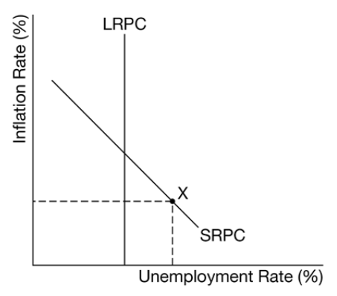
1
A
B The response states that real interest rates will increase and explains that an increase in government spending will increase the demand for loanable funds (or the decrease in taxes will decrease the supply of loanable funds), which will increase real interest rates in Canada.
C The response states that financial capital flows to Canada will increase.
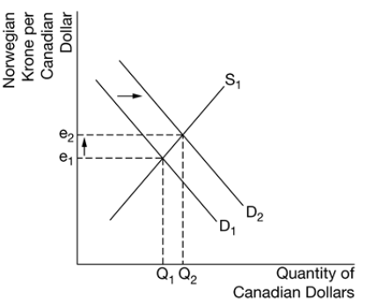
D 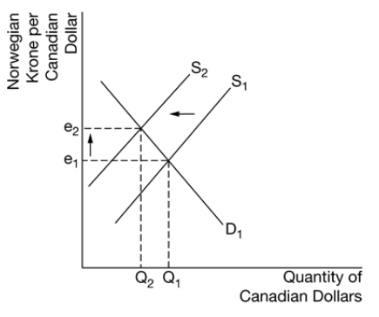
E The response states that the international value of the Norwegian krone will decrease, or the krone will depreciate.
F The response states that Norway’s current account will be in surplus and explains that the depreciation of the Norwegian krone will make Norwegian goods become relatively cheaper to Canadian buyers, which increases Norwegian exports, and Canadian goods will become relatively more expensive to Norwegian buyers, which decreases Norwegian imports.
G The response does state that Canada’s net exports will decrease.
H 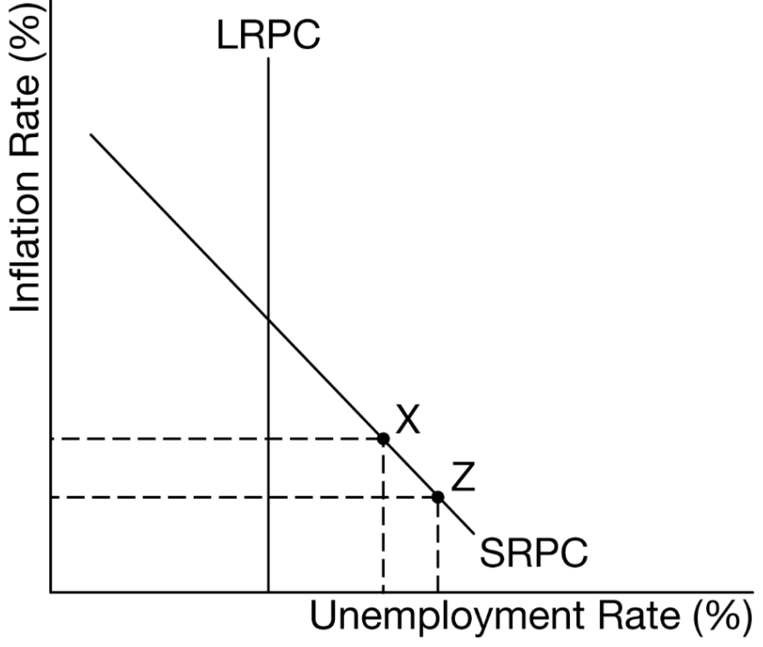

2A 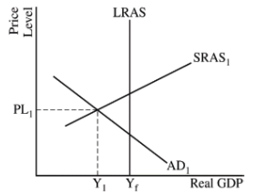
B 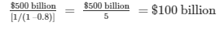
C States that the tax cut would need to be greater than the change in government spending and explains that the tax multiplier is less than the spending multiplier or explains that it would take a minimum tax decrease of $125 billion to close the output gap which is more than the minimum $100 billion government spending increase needed to close the output gap.
D 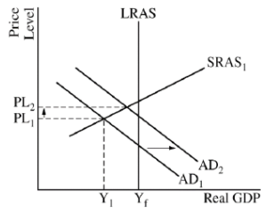
E 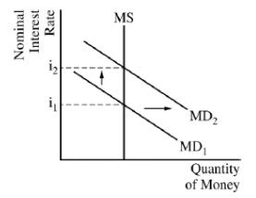
F States that real interest rates will increase.
G i States that the demand for the dollar in the foreign exchange market will increase and explains that there will be an increase in financial capital inflows as financial investors seek higher returns in the United States.
ii States that the stock of physical capital will decrease and explains that higher real interest rates will discourage investment spending on physical capital.
3.
A CA + CFA = 0
B 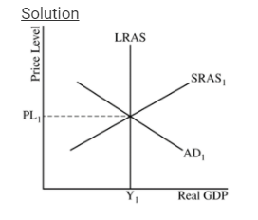
C 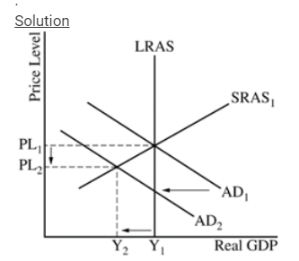
D policymakers would be more concerned about cyclical unemployment than inflationary pressures and explains that the decline in exports to the United Kingdom lowered real output below full employment, resulting in unemployment above the natural rate of unemployment.
E Swedish central bank should buy bonds.
F 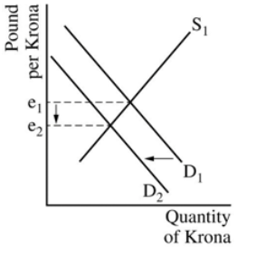
G Sweden’s central bank should sell bonds.
H selling bonds would decrease the money supply and increase interest rates in Sweden, which would increase financial capital inflows into Sweden and increase the demand for the krona, thereby leading to an appreciation of the krona.

